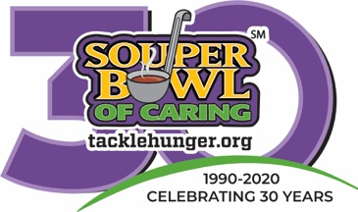

**INSERT NAME HERE**

**INSERT NAME HERE**

In 1990, Souper Bowl of Caring began with a simple prayer from a single youth group:

**“Lord, even as we enjoy the Super Bowl football game, help us be mindful of those without a bowl of soup to eat.”**

Since then, more than $150 million has been generated for local charities across the country through Souper Bowl of Caring. It has become a powerful movement that transforming the time around the Big Game, into the nation’s largest celebration of giving and serving.

Through this mission, young people learn to make a positive difference in the world as they collect food, raise money and serve at hunger-relief charities and show caring and compassion in local communities across the country.

Share in God’s love for our neighbors in need and give generously on Super Bowl Sunday. 100% of every dollar or food item collected will go directly to our Souper Bowl of Caring Charity of Choice:

**To learn more, visit: TackleHunger.org**

In 1990, Souper Bowl of Caring began with a simple prayer from a single youth group:

**“Lord, even as we enjoy the Super Bowl football game, help us be mindful of those without a bowl of soup to eat.”**

Since then, more than $150 million has been generated for local charities across the country through Souper Bowl of Caring. It has become a powerful movement that transforming the time around the Big Game, into the nation’s largest celebration of giving and serving.

Through this mission, young people learn to make a positive difference in the world as they collect food, raise money and serve at hunger-relief charities and show caring and compassion in local communities across the country.

Share in God’s love for our neighbors in need and give generously on Super Bowl Sunday. 100% of every dollar or food item collected will go directly to our Souper Bowl of Caring Charity of Choice:

**To learn more, visit: TackleHunger.org**